**Overview**

The DisplayImageComparerActivity captures the current display image and then compares it with the reference image (which may contain masks). An image is produced showing any differences between the actual phone display image and the reference image.

The test report needs to contain these three images (not necessarily displayed to the user in this order):

1. The actual phone display image.

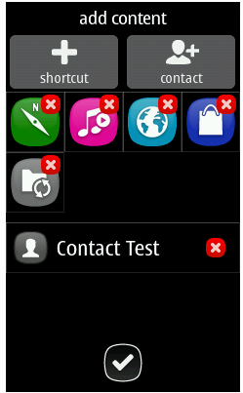

1. The reference image with the mask areas shown.  
   Note that the original reference image will only have the mask areas as XML meta-data, so it is necessary for these mask areas to be coloured in, in order to show them to the user:  
   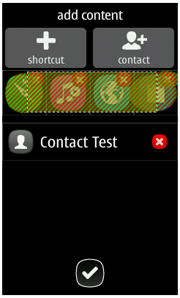
2. The differences image with the differences marked in red (as well as any masked areas shown):

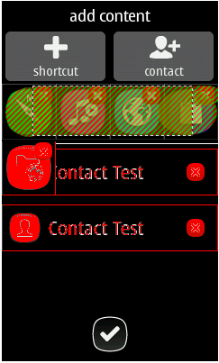

**Proposed solution**

**1) Actual image does not match the reference image**

If the actual phone display image does not match the reference image then the test report should show 3 images (the actual image, the image showing the differences and the reference image with any masks). Ideally these images should be shown in the report adjacent to each other so that the user can easily compare and see the differences:



Actual image Differences Reference image

The XML produced for the report should match this (i.e. produce XML for 3 image files).

**2) Actual image matches the reference image**

If the actual phone display image matches the reference image then the test report should show 2 images (the actual image and the reference image with any masks). There is no need to display the image with the differences, since there are no differences (outside of the masked areas).

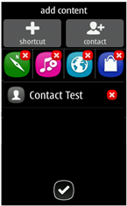

Actual image Reference image

The XML produced for the report should match this (i.e. produce XML for 2 image files).

The test report may display a symbol to the user to indicate whether the actual phone display image matches the reference image or not, e.g.

 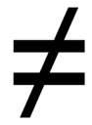

**Location of image files**

The first image is the captured image and this is stored by the framework in the “captured bitmaps” sub-directory, e.g. \captured bitmaps\capture_3.png

The proposal is for the rest of the images (i.e. difference image and reference image with masks) to be stored together with the captured image.

The activity saves the image showing the differences (marked in red) and stores it in the same directory as the capture image, e.g. \captured bitmaps\capture_3_difference.png

The activity saves the reference image with the mask area coloured in and stores it in the same directory as the capture image, e.g. \captured bitmaps\capture_3_reference.png

**XML report information**

The XML format for the test report display image comparison information should match the style of the existing XML, e.g. all XML element names and attribute names in lower-case.

An example of the current XML test report produced is shown below:

<?xml-stylesheet type='text/xsl' href='../xslt/test_report_xml_to_html.xslt'?>

<testreport test_group_filter="" time="14:02:17" date="2012-09-04" author="mfreed">

<product name="S40 eVo" main_display="MD240X320" imei="004402133756902">

<version type="sw">Vp aqdCEX12w35

30-08-12

RM-902

(c) Nokia </version>

<version type="hw">not available</version>

<version type="granite server">1.002</version>

</product>

<testcase result="Failed" id="Studio Test Case#1" type="scripted" date="2012-09-04" time="14:02:22" subarea="Studio" feature="Unknown">

<comment reason="Executing test case in whitebox mode" />

<comment reason="capture()" />

<teststep name="'capture screen content'" timeout="10000" id="1" stepId="15">

<config max_isi_data_length="49152" bitmap_capture="yes" keypress_wait="100" keypress_length="100" background="no" id="2" />

<sx id="3">dump</sx>

<capture name="capture screen content" id="4" />

</teststep>

<summary id="1" name="'capture screen content'" stepId="15">

<capture>

<xml> ...

</xml>

</capture>

<capture id="4">

<bitmap format="13" little_endian_cpu="yes" screen="1" x="0" y="0" width="240" height="320" background="no" name="capture_1.png" />

<animation name="evo_icon_contacts_xl.png" x="12" y="31" width="42" height="42" />

<animation name="evo_icon_calendar_xl.png" x="70" y="31" width="42" height="42" />

<text x="5" y="81" width="56" height="17">Contacts</text>

<text x="121" y="81" width="56" height="17">Messages</text>

</capture>

</summary>

</testcase>

<summary>Ran 0 tests in 0.0 </summary>

</testreport>

In keeping with the existing XML test report format, where a testcase can consist of a number of teststeps the display image comparison information should be enclosed within a teststep:

<teststep name="Display image comparison teststep">

<-- Display image comparison information goes here -->

</teststep>

In the situation where the current display image does not match the reference image, the following XML would be produced containing information about the 3 images:

<teststep name="Display image comparison teststep">

<displayimagecomparison name="Display image comparison" result="Failed" >

<image name="Actual image" type="ActualImage" filename="capture_3.png" />

<image name="Image showing differences with the reference image" type="DifferenceImage" filename="capture_3_difference.png" />

<image name="'Idle' reference image" type="ReferenceImage" filename="capture_3_reference.png" />

</displayimagecomparison >

</teststep>

In the situation where the current display image matches the reference image, the following XML would be produced containing information about the 2 images:

<teststep name="Display image comparison teststep">

<displayimagecomparison name="Display image comparison" result="Passed" >

<image name="Actual image" type="ActualImage" filename="capture_3.png" />

<image name="'Idle' reference image" type="ReferenceImage" filename="capture_3_reference.png" />

</displayimagecomparison >

</teststep>

**Issues**

1. The existing teststeps produced by the framework has the following XML attributes:   
   timeout="10000" id="1" stepId="15"  
     
   Is there any requirement to have any of these XML attributes in the teststep that contains the display image comparison information?

These are not required.

Id tag is just used as a running number inside the teststep tag (to help debugging granite server error messages).

1. It is good practice to produce an XML Schema describing the XML and to use this to validate the XML against the schema, but this may be difficult to do in Granite with the existing XML test report information.  
     
   Should we consider doing this or not?

We may consider doing this later on.

We should later do some reformatting/cleaning of the report format and then do the schema also.